Statistical Report
B812109041 Isaac Lee
- Background introduction
The inspiration for this experiment comes from the common habit of many people listening to music while working or studying. Previous experiments have indicated that certain types of music stimuli can enhance memory performance. For example, the Mozart effect suggests that listening to Mozart's Piano Sonata K448 can enhance spatial reasoning abilities [1]. Therefore, this experiment aims to explore whether other types of music can achieve similar effects or decrease memory performance. Through two indicators, namely brainwave spectral energy and memory test scores, the experiment aims to investigate the impact of different types of music stimuli on memory performance. Furthermore, the goal is to identify music that can effectively enhance or decrease memory performance and apply the results to people's daily lives as a simple way to improve work efficiency.

- Brief method description
  - Experimental Procedure
The experiment consists of two parts: music stimulus and memory test. Each trial involves three types of music stimuli, and the duration of each experiment is 90 minutes. The experimental procedure is illustrated in the diagram below. At the beginning of each trial, the participant's relaxed brainwaves are measured, followed by a pre-test of memory. Subsequently, the participant undergoes music stimulation while in a relaxed state, and their brainwave data during music listening are recorded. After the stimulation, the participant undergoes a post-test of memory. This sequence is repeated for three different types of music stimuli, with the order of music stimuli being randomized. Corresponding memory test scores are obtained for each stimulus. The order of music stimuli is randomized, and there is a three-minute break before and after each memory test to avoid interference.

- Evaluation of Memory Scores
This report aims to statistically analyze the memory scores obtained by 20 participants in the memory test. The scores can be divided into four conditions: relaxed state (F_total), classical music (C_total), electronic music (E_total), and metal music (M_total). The scores in the relaxed state serve as the baseline. The experiment seeks to investigate two main themes:
1. Whether there is a statistically significant improvement in memory scores after music stimulation compared to the relaxed state.
2. Whether there are significant differences in memory performance after different music stimuli.

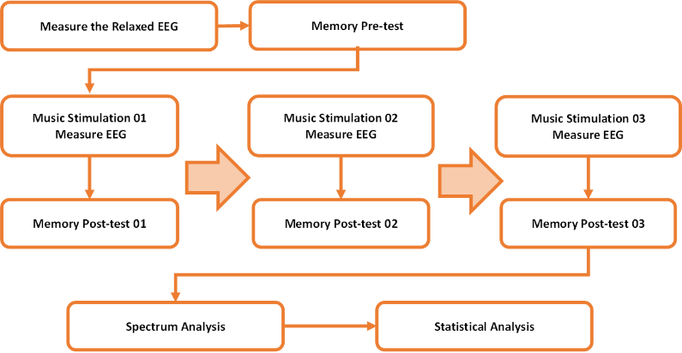
Fig. Experimental Procedure

- Hypothesis testing (the five steps)
- Statistical Improvement in Memory Scores after Music Stimulation Compared to the Relaxed State
- Hypothesis
H0: There is no significant improvement after music stimulation compared with before stimulation.
Ha: There is significant improvement after music stimulation compared with before stimulation.
- Assumption: No specific assumption of normal distribution (N=20)

- Testing: Wilcoxon signed-rank test / significance level = 0.05
Classic vs. Relax:
    - P-value: 0.06036922
    - Conclusion: No significant difference at α=0.05, but close to significance.
Electronic vs. Relax:
    - P-value: 0.01228171
    - Conclusion: Significant difference at α=0.05
Metal vs. Relax:
    - P-value: 0.08324039
    - Conclusion: No significant difference at α=0.05.
- Effect Size: No statistics in sign test, so no effect for this test
- Decision:
Only the improvement in memory scores after exposure to electronic music exhibits a statistically significant difference, whereas there is no significant difference observed for classical and metal music.

- Whether There Are Significant Differences in Memory Performance after Different Music Stimuli
- Hypothesis
H0: There is no significant difference in memory scores among different music stimuli.
Ha: There is a significant difference in memory scores among different music stimuli.
- Assumption:
- Normality: Only M_total does not adhere to normal distribution.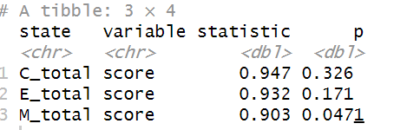
- Homogeneity of Variance: The results indicate that the variances are equal among different states (p > 0.05)
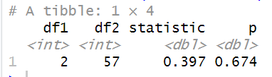

- Testing:
- Kruskal-Wallis Tests
Due to insufficient data size and the non-normal distribution of M_total, the Kruskal-Wallis test is used.
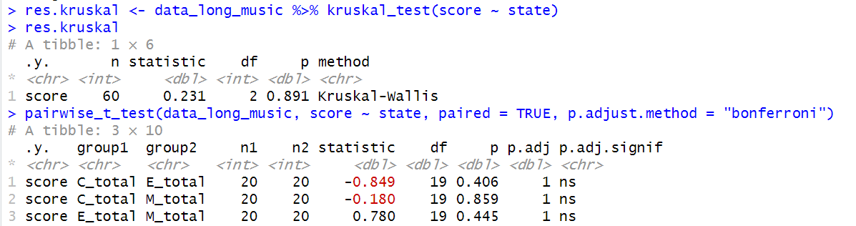
This result indicates that there is no significant difference in the distribution of scores among different groups (C_total, E_total, M_total) (p-value = 0.891 > 0.05). Thus, we fail to reject the null hypothesis, suggesting that there is no significant difference between groups.

- Post-hoc Tests
 The paired t-test further confirmed this result, showing that the comparisons between each group are not significant.

- Effect Size:
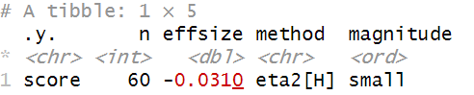
The effect size of -0.0310 indicates that there is a very small proportion of variance in scores that can be explained by the different music stimulus groups. This supports previous findings that there are no significant differences between the groups. Therefore, it can be concluded that even if there are significant differences in score changes before and after music stimulation, the effect size is very small.
- Decision:
Based on the results of the Kruskal-Wallis’s test and post-hoc tests, there are no significant differences between the different types of music.

- Estimation of sample size (for preliminary study)
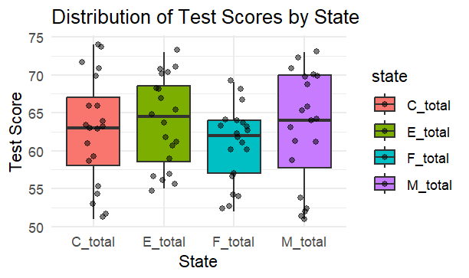
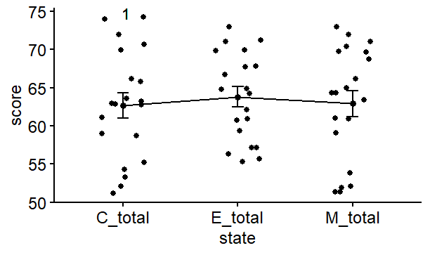Distribution of sample size by state
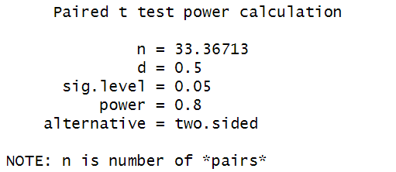
Based on the current results, if we want to achieve a power of 0.8 in future studies and be able to detect a medium effect size (0.5), we need approximately 34 pairs of matched samples. This will ensure that our study design has sufficient statistical power to detect significant differences.

- Brief conclusion at the status
1. Differences between Relaxation State and Various Types of Music
- There is a significant difference between the relaxation state and electronic music.
- There is no significant difference between the relaxation state and classical music, but it is very close to the significance level.
- There is no significant difference between the relaxation state and metal music.
2. Differences among Different Types of Music
- There are no significant differences among different types of music (classical, electronic, metal).

- Reference
[1] Pauwels, Volterrani, 2014, "Mozart, music and medicine"

